ASSIGNMENT-01
NAME : Danduboyina Rajeev
EMAIL : rajeevrajeev91982@gmail.com
TITLE : DATA ANALYTICS WITH TABLEAU
ROLL NO : 23AK5A3308
COLLEGE : AITS-TPT
“The following visualizations are created to clearly represent the data.”
- Bar Chart
- Pie Chart
- Stacked Bar Chart
- Line Chart
- Bubble Chart

1.BAR CHART
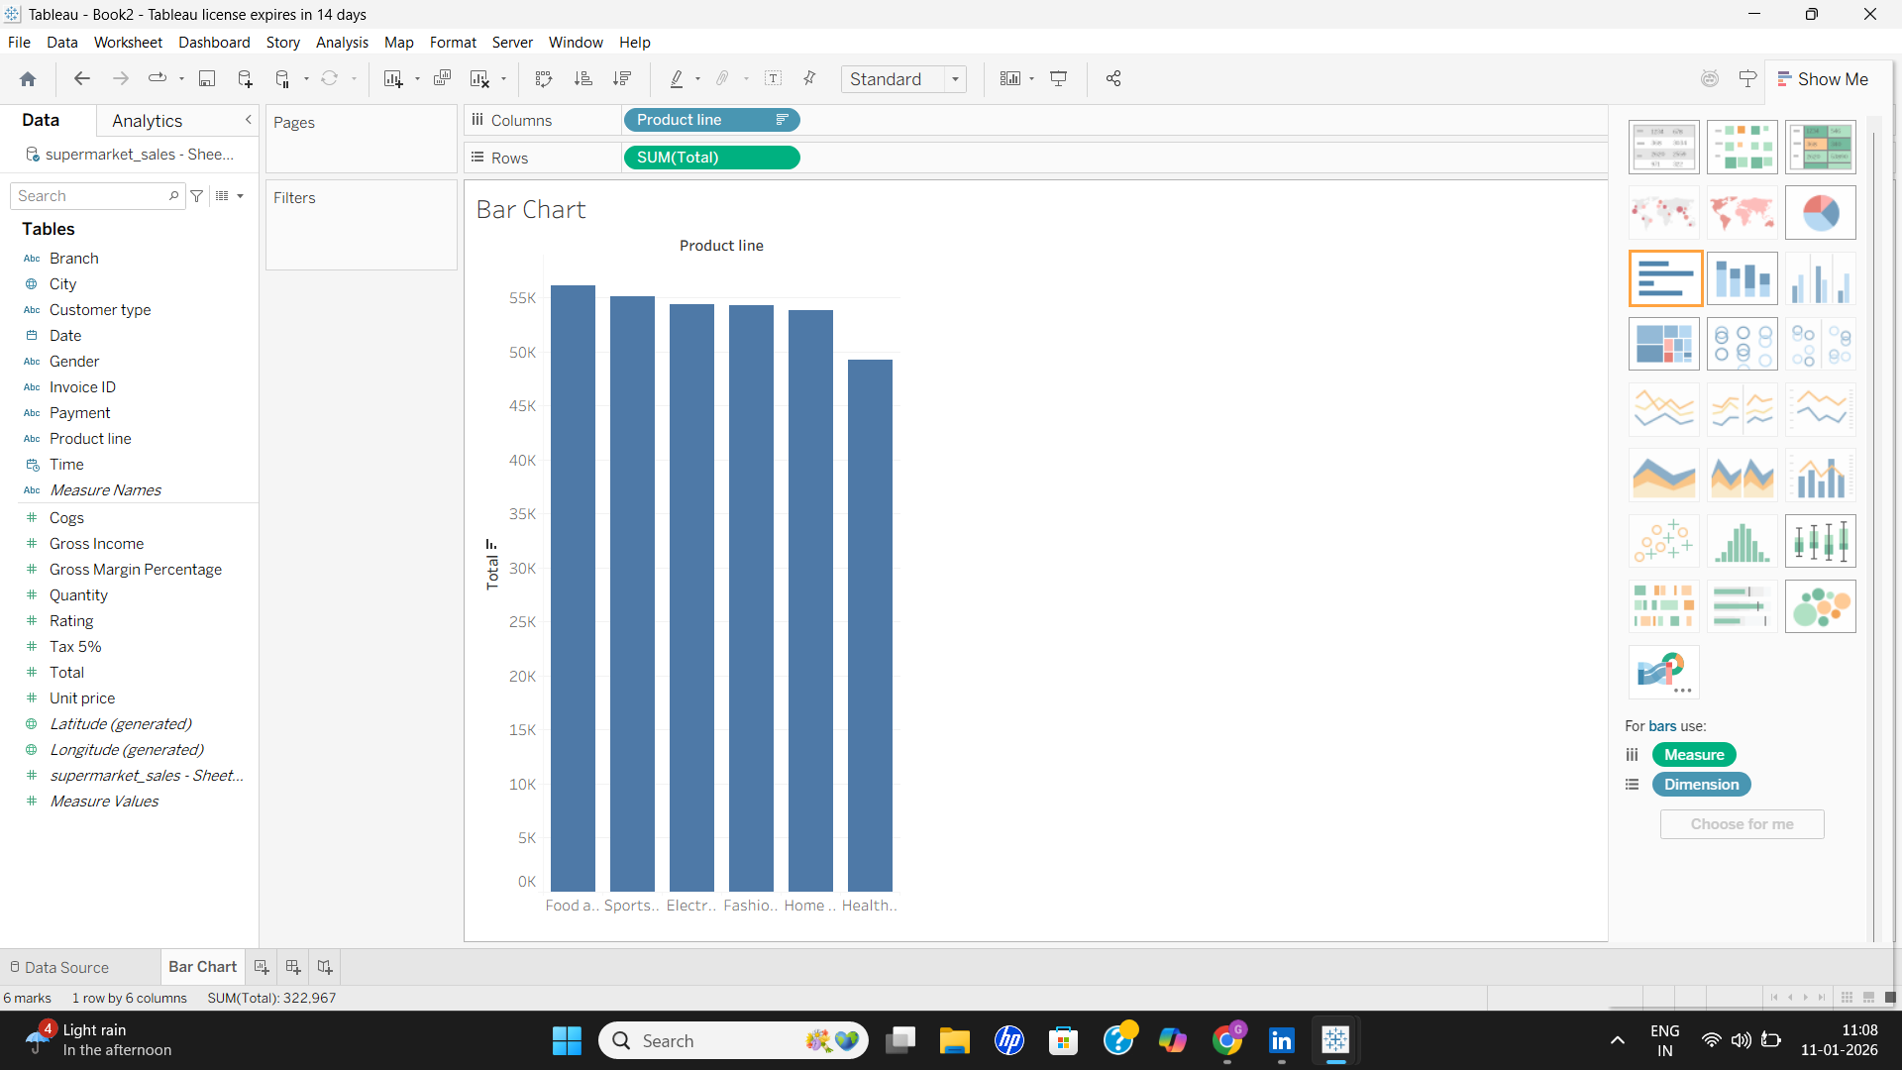
2.PIE CHART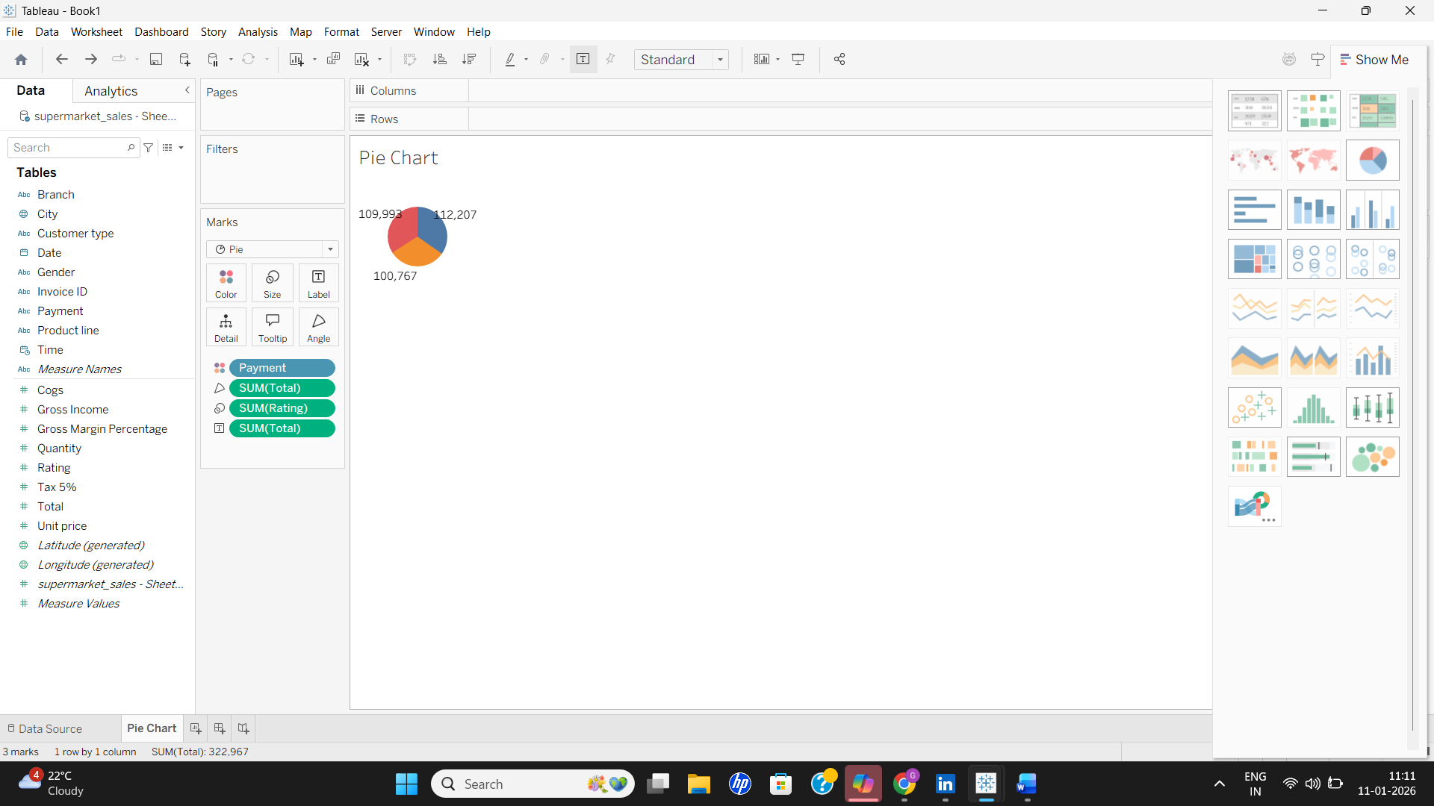

3.STACKED BAR CHART
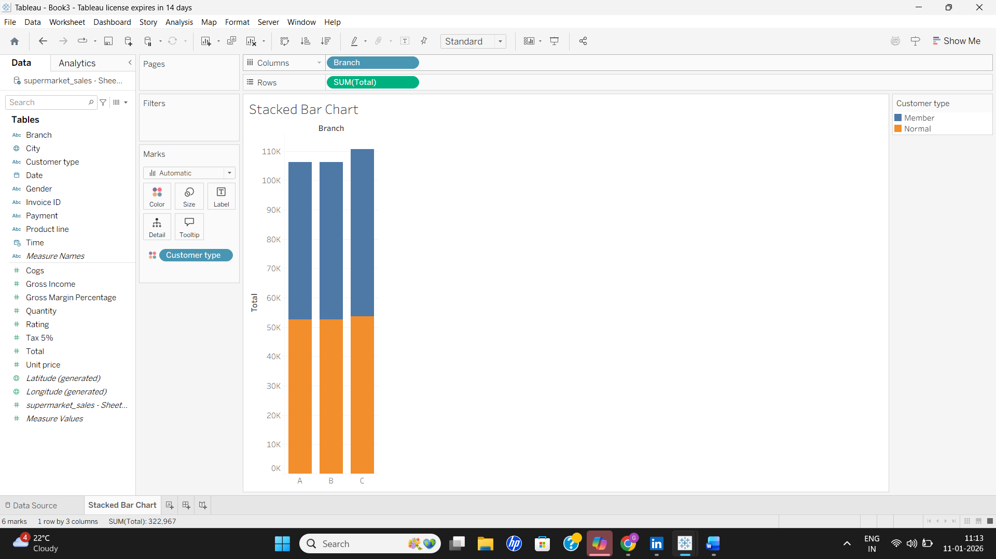
4.LINE CHART
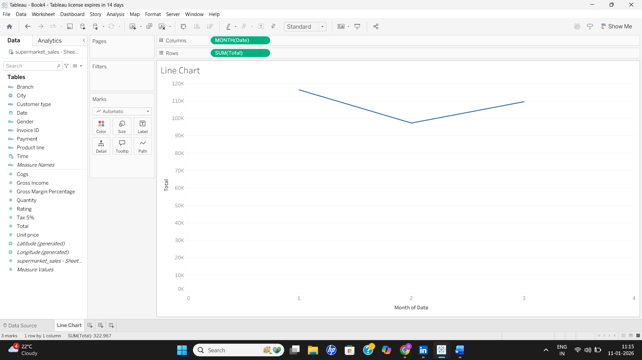

5.BUBBLE CHART
